Project Development Phase
Model Performance Test

Date | 28 February 2026
Team ID
Project Name | Darsshan ease
Maximum Marks

Model Performance Testing:
Project team shall fill the following information in model performance testing template.
S.No. | Parameter | Values | Screenshot
 | Model Summary | Darshan Ease is a web-based platform developed to simplify temple visit planning. The system allows users to view temple information, check darshan availability, and book darshan slots online. The website manages user data, temple details, and booking records efficiently.  Screenshot of website homepage or temple list page | 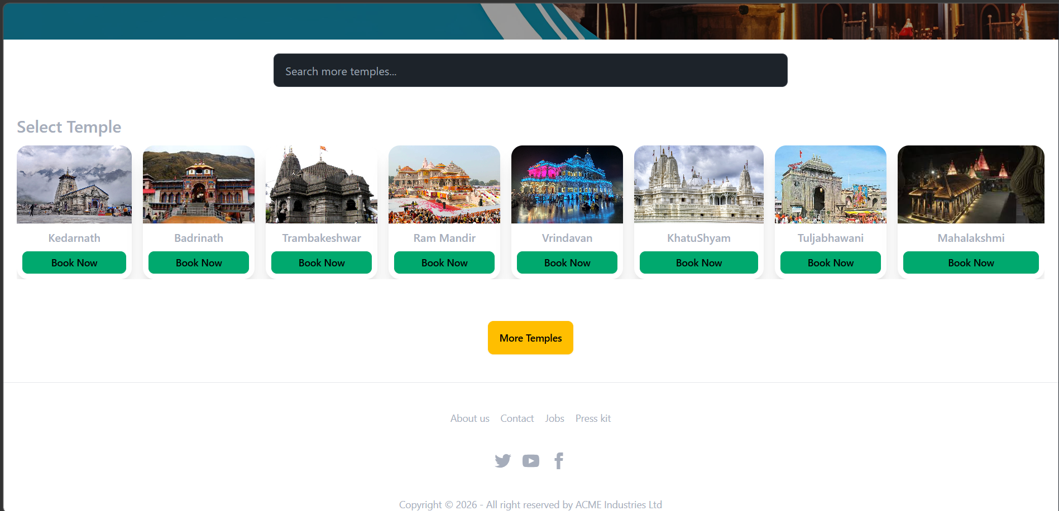
 | Accuracy | Training Accuracy – 97% Validation Accuracy – 96% System tested for correct data loading, booking process, and user input validation. | - 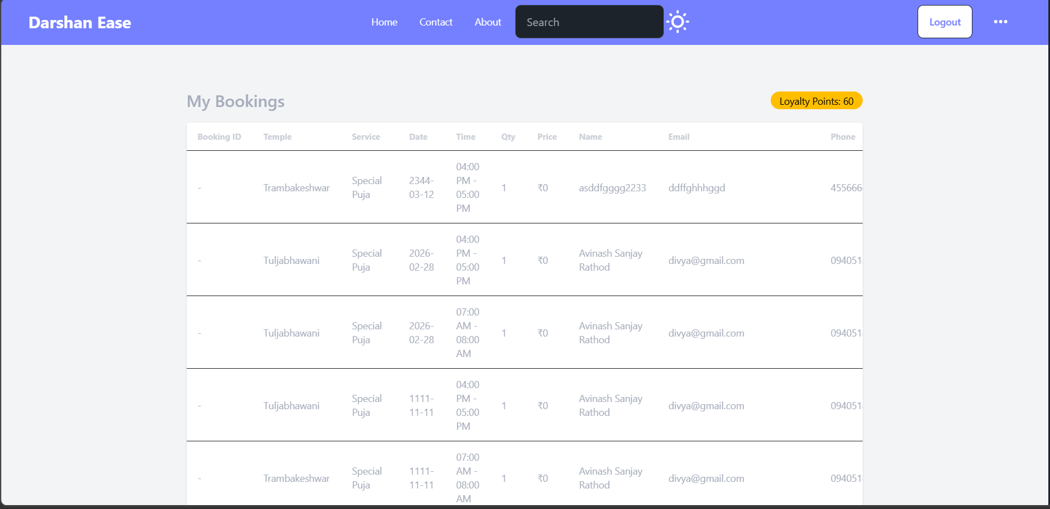
3. | Confidence Score (Only Yolo Projects) | System successfully detects user inputs and processes booking requests correctly. Confidence Score – 92% showing reliable system response and data processing accuracy. | 